SGW Digital Grain Hardness Tester User Manual
- Usage
AGW digital grain hardness tester is used for scientific research and teaching of agricultural,especially used for testing the hardness of grain（wheat, rice）adopt advanced testing technology,with the characteristic of high accuracy, strong indication, high resolution, easy operation, durable and reliable. With its beautiful outlook, it can be measured by hand on site, it also can be tested in the workbench in the lab.
- Characteristic
- Digital display, easy for reading and high accuracy
- Light weight, small size and easy for carrying
- Two units : Kg and N switch into each other
- The battery has short circuit ,leakage and overload protection , adopt 3.7V Lithium battery power supply, will shut down automatically without operation within 10 minutes
- Two measuring modes: Real time and Peak mode.
- Outline structure
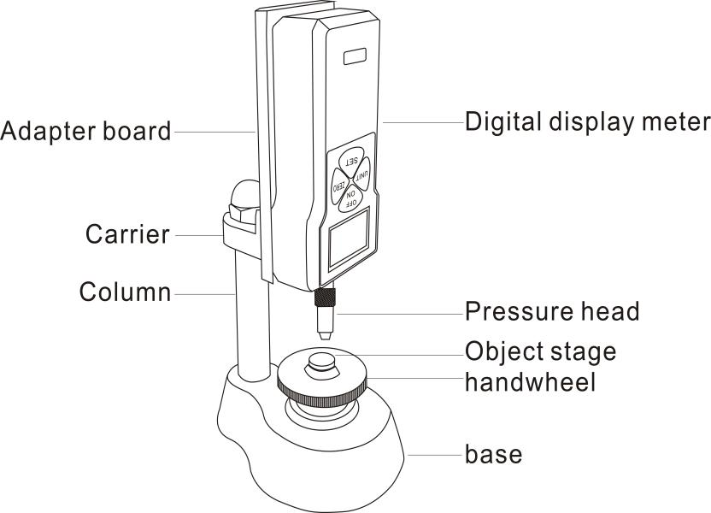

- Specifications
Model | SGW-20
Max. Load | 20kg
 | 196N
Load division value | 0.01kg
 | 0.1N
Load cell | Inner
Accuracy | ±2％
Power | 3.7V Lithium battery
Charger time | 4~6 hours
Battery Continuous use | About 15 hours
Battery life | ≥300 times
Charger | Input：AC 100-240V 50/60HZ Output：DC 5V 1000mA
Working temperature | 5℃～35℃
Transport temperature | -10℃～60℃
Relative humidity | 15％～80％RH
Working environment | No source and corrosive media around
- Screen Display
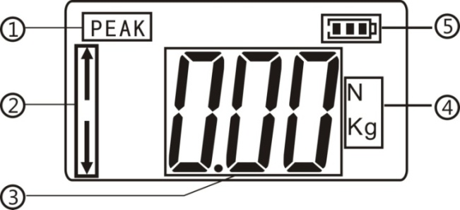
①Peak mode：Turn on and enter into measurement interface,press “SET”key to enter into “PEAK MODE”, it is to record the max. Measurement load force during a period of time.
②Force direction：“↑”means pull force, “↓”means push force.
③Hardness value display.
④Two units：kg and N, press “UNIT” button to switch into each other.
⑤Power display.

- Key description
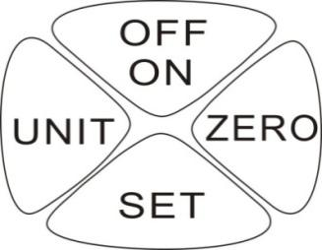
OFF/ON: ON/OFF key
ZERO： Press “ ZERO” key to clear the data on the screen.
SET：When in measurement interface, press “SET” key to enter into Peak mode . Press “SET”key for 5-6 seconds to enter into setting interface.
UNIT：Press “UNIT” key to choose unit. Press “UNIT” key for5-6 seconds to turn over the value on screen.
- Boot display
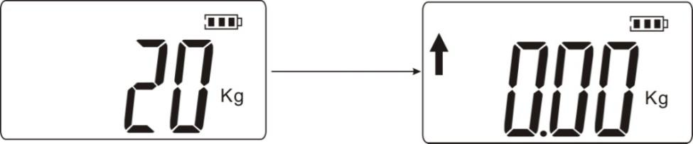
- Features
Setting interface：
When in measurement interface, press “SET” key for 5~6 second, then it will enter into setting interface, it shows ”HIDT”on the screen ,and then press “UNIT” button continuously, it will appear “LODT”、“L.SET”、“OFFT”、“G.SET”、“BAC.S”、“REF”、“R.SET” in turn ,as the picture show below :
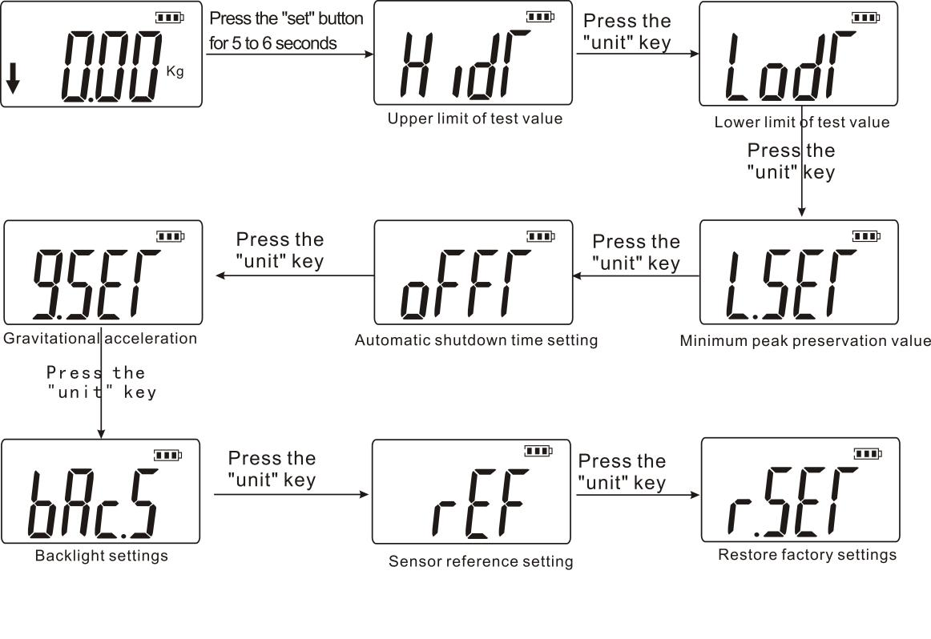

（HIDT）Test value upper limit value setting:The default value of upper limit value is 100% of full range. If higher than the range means out of range ,the instrument will beeping. If you want to reset the upper limit value ,you can press“UNIT” and“ZERO”for resetting. Press “SET” key to return to setting interface ,as the picture below:
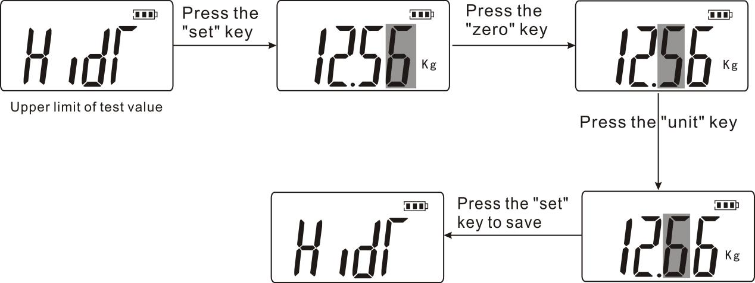
（LODT）Test value lower limit setting:The default value of lower limit value is 0. If lower than the limit value ,the instrument will beeping .If you want to reset the lower limit value ,press “UNIT” and “ZERO” for setting. Press “SET” key for saving and then return to the setting interface .
（L.SET）Peak Min. Storage value: In the peak mode, if the present value smaller than the value ,the peak value can not be saved.
（OFFT）Auto shut down time setting:when in this mode,please press “UNIT” key and “ZERO” key for setting,it can set auto shut down from 1 to 9999 minutes,it can also set “00” for not auto shut down. If you select not auto shut down,press “set’ key to complete.Then return to option interface.The default setting of instrument is 10 minutes.
(G.SET) Acceleration of gravity setting:the users can set acceleration of gravity according to their area.The default value is 9.800.
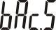（bAC.S）Back light function setting：when in this mode please press “UNIT” key for optional，if you select “(YES)” means open back light function,if you select”（NO）” means close back light function, then press “SET” key for saving and return to setting interface.
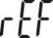 (rEF)Sensor reference setting：This option do not need to be set.
（R.SET）Return to factory setting,when in this mode,press “SET” key will return to factory setting,the instrument will show down.Turn on the instrument again for using.
- How to use it ?
1 Turn on the instrument ,and enter into measurement interface, choose the real time mode or peak mode as your requirements.
2 Put the grain on the platform(better vertical),and then rotate the wheel to move up until the grain break,at the same while ,the digital display show the testing value.
3 If you need to test again,clean the platform ,and press “ZERO” to clear the screen,and do as the step 2.
4 After testing, clean the testing platform,turn off ,put the clamp down ,put all accessories in the tool box for next usage.
- Safety Precautions
Note:
- When the power is running low ,it need to charge 4~6 hours can be normal using.
- Any error operation may damage the instrument or cause serious accident.This manual indicates important matters about how to prevent accidents and the usage of instrument,please read this instructions carefully before using,keep it securely in preparation for reading again.
Warning:
- Do not use damaged or bending clamps.
- Do not use this instrument overload,otherwise the sensor will damaged ,even cause an accident.
- When the tested result exceed 100% of full scale,the buzzer will beeping continuously,please release the added load immediately at this moment or reduce the load ;when the tested result exceed 120% of full scale, the instrument will damaged .

To solve the crash state: When the instrument crash by accident ,please press the “RESET” key with a small piece of hard objects .

Safety precautions:
- The charger should match the instrument ,otherwise it will cause a circuit failure even cause a fire .
- Do not use the power supply over the range of voltage,otherwise it will cause electric shock or fire.
- Do not pull or plug the charger with wet hand ,otherwise it will cause electric shock.
- Do not pull or drag the power wire to unplug the charger, in order to avoid the electric shock.
- Please use soft cloth to clean the instrument. Immerse the cloth into the water containing detergent, wring it dry and then clean up the dust and dirt.Do not use volatile chemicals to clean the instrument (such as volatile agent, thinner, alcohol, etc.)
- Do not operate the instrument under below environments:
①Humid environment ②Dusty environment ③Where to use oil or chemical ④The place where is a source
- Please use the instrument under the specified temperature and humid range ,otherwise it will cause the instrument error.
- Don't repair or disassemble it by yourself, or it may case the machine permanent fault.
- Other safety cautions should be noted .
- Please confirm the symptom before repaired
Power | symptom | Reasons and or phenomenon | method
 | No display on screen when press “ON” | The battery no power | Re-charger
Tested value | The tested result is not accurate | Big error | It need to recalibration at factory
others | Crash by accident | Press button no response | Press “RESET” key by needle

- Packing list
Digital Grain Hardness Tester | One set
Charger（5V） | One piece
User manual | One piece
Warranty card | One piece
Check certificate | 1piece
Dryer | 1piece
Hex nuts（M6） | 1 piece
Height adjustment table A/B | One for each

